**Trajectory Generation Background**

In motion planning, a path is defined a set of possible ways a vehicle is allowed to go from Point A to Point B. While trajectory is defined as the profile needed to go through that path given different constraints. For example, many trajectories can lie inside of a given path as shown in Figure 1. Given constraints can be in the form of differential constraints from equations of motion, geometrical constraints or dynamic constraints from vehicle limits.

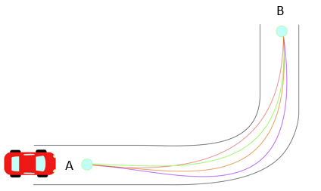

In autonomous vehicles,